**DAILY ONLINE ACTIVITIES SUMMARY**

|  |  |  |  |  |  |  |  |  |
| --- | --- | --- | --- | --- | --- | --- | --- | --- |
| **Date:** | **16/6/2020** | | | | | **Name:** | **Nivedita** | |
| **Sem & Sec** | **4th sem/ A-sec** | | | | | **USN:** | **4al18cs053** | |
| **Online Test Summary** | | | | | | | | |
| **Subject** | | **maths** | | | | | | |
| **Max. Marks** | | **30** | | **Score** | | | **22** | |
| **Certification Course Summary** | | | | | | | | |
| **Course** | **Linux essential** | | | | | | | |
| **Certificate Provider** | | | **Cisco networking** | | **Duration** | | | **40 hours** |
| **Coding Challenges** | | | | | | | | |
| **Problem Statement:** **] Write a Python program to check whether a given a binary tree is a valid binary search tree (BST) or not?** | | | | | | | | |
| **Status: done** | | | | | | | | |
| **Uploaded the report in Github** | | | | | **yes** | | | |
| **If yes Repository name** | | | | | [**https://github.com/nivi-nivedita/lockdown-coding-program**](https://github.com/nivi-nivedita/lockdown-coding-program) | | | |
| **Uploaded the report in slack** | | | | | **yes** | | | |

Online Test Details: today maths test at 3pm of 30 marks and 15 questions.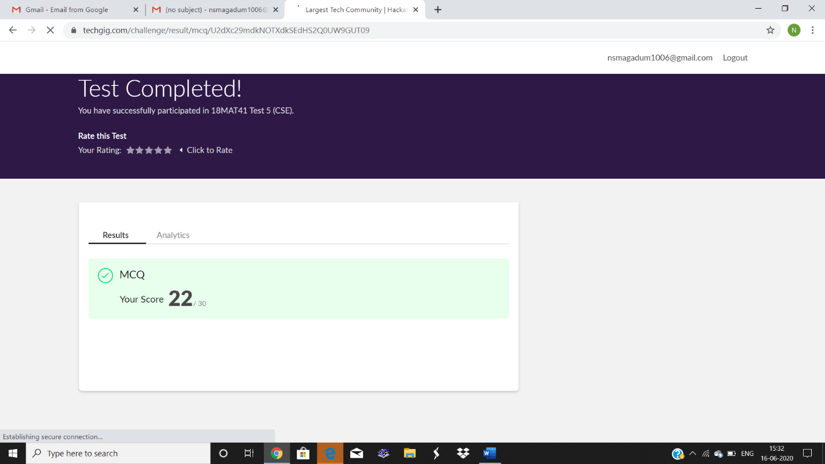

Certification Course Details: I continued same course and completed 3 modules and midterm exam.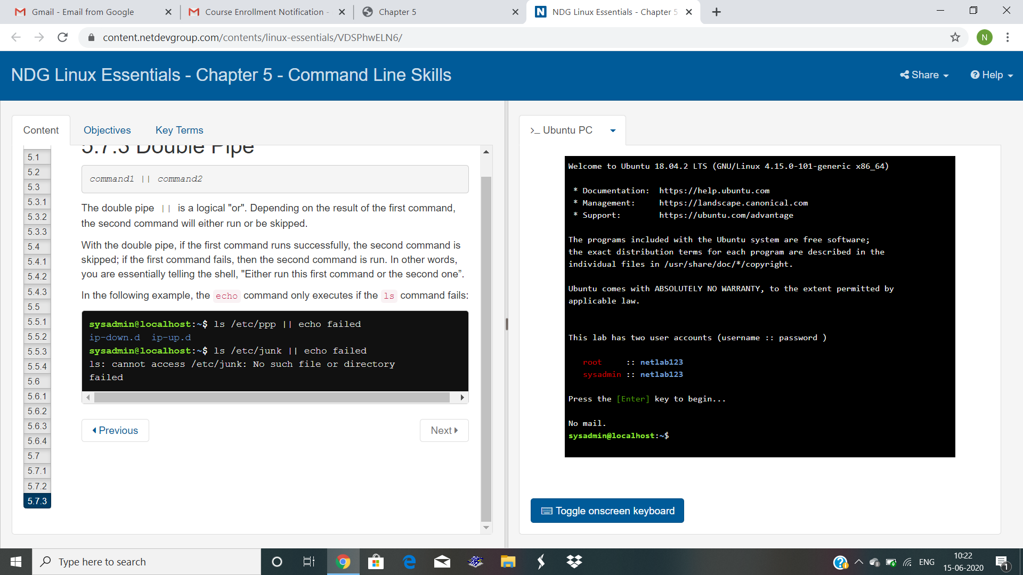

Then watched webinar.

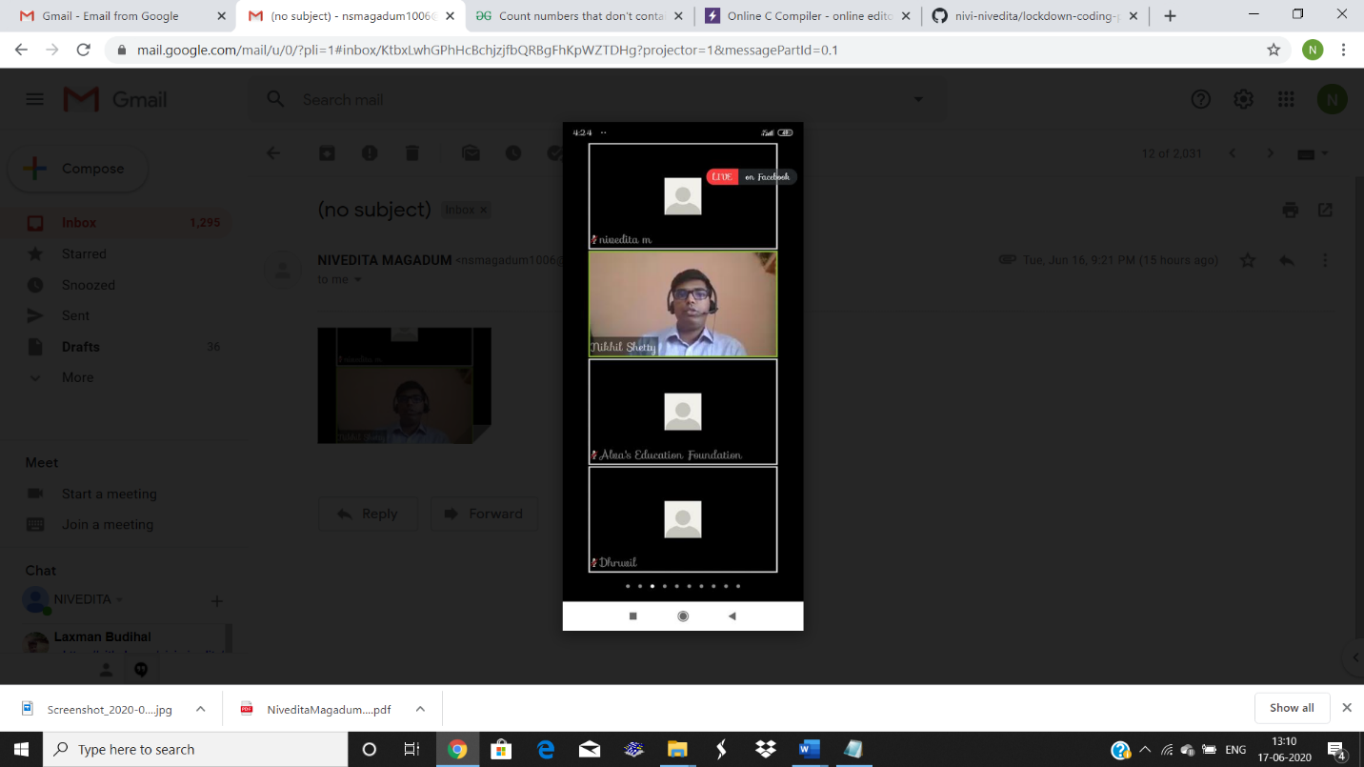

Coding Challenges Details: Write a Python program to check whether a given a binary tree is a valid binary search tree (BST) or not?

Executed and uploaded.

